The University of Tennessee
Research Council
Minutes of the Meeting
January 10, 2018

Elected Members present:
Yuri Efremenko, David Icove, Julia Jaekel, Juan Jurat-Fuentes, Qiang He (Chair), Michael Kilbey, Jacob Latham, Andreas Nebenfuehr, Casey Sams, Soren Sorensen, and Xiaopeng Zhao

Ex-Officio Members present:
Teri Baxter, Steven Blackwell, Chris Boake, Holly Mercer, Robert Muenchen, David White, and Robert Nobles

Call to order:
Qiang He called the meeting to order. A regular meeting of the Research Council was held at Blount Hall room A004 on January 10, 2018. The meeting called to order at 3:35 pm.

Approval of Minutes:
Minutes from the October and December meetings were approved. One notation to the October minutes to add Michael Kilbey’s attendance.

Announcements and Reports

March Research Council Meeting
A motion was made and seconded to move the March meeting from March 17 to March 7 to avoid the Spring Break week. Paula Brown will send out an updated meeting announcement. The Zoom link will remain the same.

Core Facilities Equipment and Infrastructure Fund – Xiaopeng Zhao
The Equipment and Infrastructure Fund received 27 proposals requesting $530,253 in SARIF funds. The committee recommended to fund 15 of those proposals with a total award of $212,113.
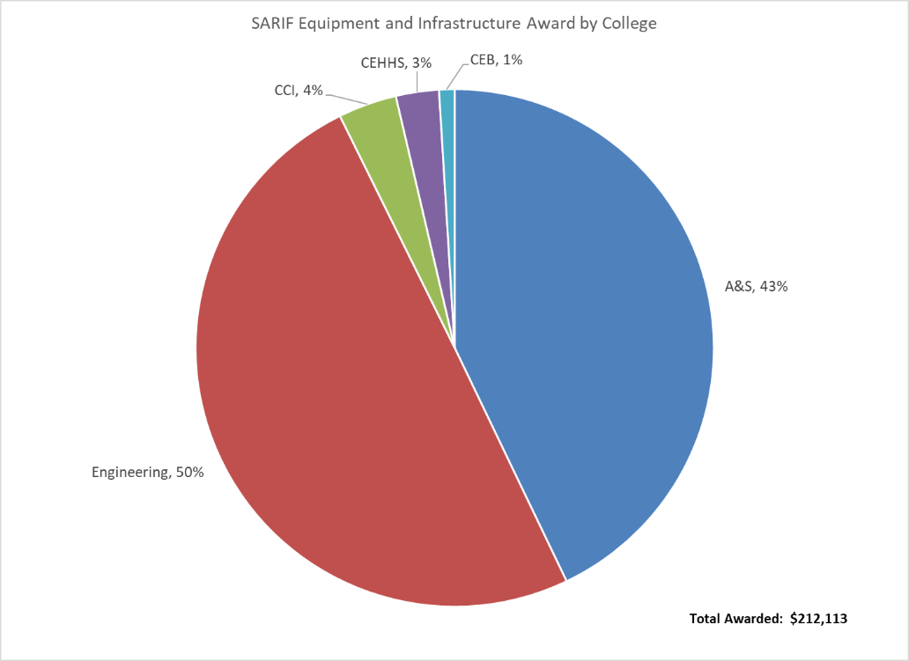

Chancellor Awards Committee – Soren Sorensen
The Chancellor Awards call for nominations was released on December 17 with a deadline of January 24, 2018. There were two multi discipline nominations, 26 Professional Promise for Research and Creative Activities, and 8 Research and Creative Activities nominations. The committee has the nominations for review and will return recommendations to the AVCRD by February 28, 2018.

Centers and Institutes Review Committee – Juan Jurat-Fuentes
The Centers are scheduled to be review this semester by the committee. The Korn Learning, Assessment, and Social Skills Center, Center for Sport, Peace and Society, and Center for Information Technology Research were notified on January 26 of the review and are scheduled to have their packages to the committee by March 28. The committee is expected to provide feedback and recommendations by May 7.

Presentations:

The UT Research Enterprise – Robert Nobles
The Office of Research and Engagement includes the Office of Research Development, Research Finance & Administration, Office of Sponsored Programs, Research Integrity, and Office of Undergraduate Research. ORE is focusing on informatics to make or guide decisions on research. Each week, ORE sends out a monthly award and proposal report. Paula Brown has an action to request the Research Council members be added to the distribution list for this monthly report. The data provides an opportunity to review the ROI from research dollars not only in internal funding awards, but also funding of research centers and institutes when compared award amounts are compared to proposal amounts.

This data is also key in recruiting and succession planning. Two-thirds of UTK current faculty can retire in 10 years which presents an opportunity to develop succession plans to capitalize on current strengths and develop other areas of strengths when recruiting for departments. However, there are competing measures between a faculty member’s department tenure goals focusing on publications vs research activity focusing on submitting proposals. How to increase number of proposals submitted? Hiring ‘new blood’ with a specific focus on research. This is one reason the Chancellor has developed the Cluster Hire initiative; just recently releasing the Data Science Cluster proposal as well as three additional open calls for proposals. ORE will also create funding portfolios to align faculty to research endeavors beginning in year two instead of year three.

ORE has $38M operating budget with $4M in salary. ‘Should the Research Council have input in ORE’s budget?’ RC member expressed the desire to have input in the budget process to align research initiatives. Dr. Nobles answered that the Research Council’s responsibility is to ensure their department and colleges’ have developed and implemented their strategic plans which will allow each to have input. However, the Research Council is probably not the correct group to determine budget for ORE. An RC member expressed concern that no additional dollars were requested for this year. Dr. Nobles stated that it is a fine balance between providing research funds and not dis-incentivizing the desire of faculty to request external funds.

The new VCR, Victor McCrary will arrive March 5. He will be invited to attend the Research Council meeting as his time allows.

Adjournment: The Chair adjourned the meeting at 5:10pm.

Minutes submitted by: Paula Brown

Next Meeting: February 14, 2018 @3:30 pm in Blount Hall A004.
Zoom Attendance: https://tennessee.zoom.us/j/705429195, please confirm with Paula Brown

